PR REVIEW
SCC-4487 | Add Segment to Inside Sales Order
GreatPlainsDevA | Declarative metadata pull-request assessment
Review target | SCC-4487 implementation in GreatPlainsDevA (org 00DEa00000Fc086MAB)
Review date | 28 August 2026
Evidence | Focused retrieve | live schema | 533-order formula comparison | UI and profile review
Decision | Implementation Approved | PR diff parity pending
Boundary | PR review only | no deployment, activation, assignment, metadata, or record changes

PR DECISION
Implementation Approved in DevA. No story-related code or metadata defect was identified. The formula, both Inside Sales placements, and effective read-only access satisfy the acceptance criteria. Because no PR URL, branch, commit, or patch was supplied, final Git PR approval is conditional on diff parity with this verified snapshot.

PR review outcome
# | Scope | Result | Reviewer evidence
1 | PR branch / diff | Boundary | No PR URL, branch, commit, or patch was supplied; approve the Git PR only after confirming its diff matches DevA.
2 | Order.Segment__c | Pass | Present as a Text formula: TEXT(Account.Segment__c); schema reports calculated=true, createable=false, and updateable=false.
3 | Inside Sales layout | Pass | Segment__c is directly after Customer_Type__c and is explicitly Readonly.
4 | Lightning record page | Pass | Record.Segment__c is directly after Customer Type, readonly, and visible only when record type name is Inside Sales.
5 | Named profiles | Pass | Admin, API-only Admin, and Standard User have effective read=true/edit=false field access.
6 | Formula results | Pass | All 533 sampled Inside Sales orders matched Account Segment: 158 Residential, 3 MDU Tenant, 372 blank, 0 mismatches.

Declarative design path
The DevA implementation is metadata-only: a text formula on Order mirrors the Account picklist at read time, the field is placed in both Inside Sales presentation layers, and the named profiles receive effective read-only field visibility.
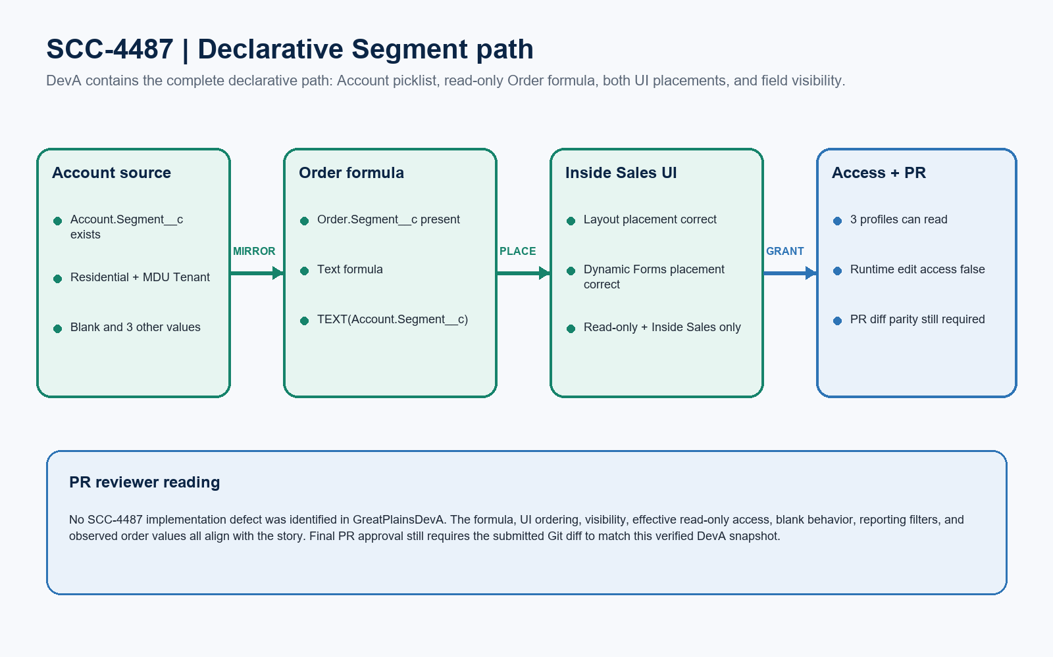
Figure 1. SCC-4487 declarative Segment path
DESIGN READING
Green components are verified in DevA. Blue marks access and the remaining PR-evidence boundary. The formula calculates at read time, so SCC-4487 does not require Apex, Flow, trigger, or persisted copy logic.

Component-by-component PR evidence
Type | Component | Observed DevA state | Reviewer evidence
CustomField | Order.Segment__c | Verified | Text formula TEXT(Account.Segment__c); label, description, and help text are story-specific.
Layout | Order-Inside Sales | Verified | Customer_Type__c -> Segment__c (Readonly) -> Additional_Information_Online_Form__c.
FlexiPage | OSE_CPQOrderRecordPage | Verified | Record.Segment__c follows Customer Type, is readonly, and has an Inside Sales visibility rule.
Profile | Admin | Verified | Field is readable; effective PermissionsEdit is false because the field is calculated.
Profile | System Administrator - API Only | Verified | Field is readable; effective PermissionsEdit is false because the field is calculated.
Profile | Standard | Verified | Field is readable and not editable; no unrelated record-type visibility change is present.

Source-field and packaging evidence
Evidence area | Observed value | Reviewer interpretation
Account.Segment__c | Picklist; editable; blank allowed | Source field exists.
Active source values | MDU Bulk; MDU Tenant; SFU; Residential; Other | Direct mirroring correctly preserves every current Account value; the ticket's two values are examples.
Order schema | Calculated; non-createable; non-updateable; nillable; filterable | Read-only, blank-safe, and usable as a report/list filter.
Observed records | 533 Inside Sales orders; 0 mismatches | Includes Residential, MDU Tenant, and blank results.
Expected package | 1 field + 1 layout + 1 FlexiPage + 3 profiles | Confirm the submitted PR contains these six components without unrelated churn.

EVIDENCE BOUNDARY
These findings are based on a focused read-only GreatPlainsDevA snapshot and live formula results. They validate the org implementation but cannot prove that an unsupplied Git branch or pull-request diff contains the same metadata.

PR findings and reviewer notes
Result | Area | Finding | Reviewer action
Gate | PR traceability | The actual Git diff is unavailable. | Attach the PR URL/branch/commit and compare the six metadata components with DevA.
Pass | Core field | The formula is implemented as designed. | No modification required if the PR contains the verified field metadata.
Pass | UI placement | Both presentation layers place Segment below Customer Type. | No modification required if the PR diff matches DevA.
Pass | Field access | All three named profiles have effective read-only access. | Do not add edit access or unrelated permission changes.
Note | Value semantics | Account currently has five active values. | Direct mirroring is consistent with 'same value'; no restrictive CASE mapping is needed.
Note | Change scope | The formula calculates at read time. | Keep the PR declarative; do not add Apex, Flow, trigger, or record-copy logic.
Note | Profile XML | Admin source XML may show editable=true. | The live FieldPermissions API reports edit=false and schema updateable=false; this is not a runtime defect.

Formula review standard
Review item | Required design | Reason
Return type | Text formula | The source is a picklist; Order must display its current label as read-only text.
Recommended formula | TEXT(Account.Segment__c) | Mirrors the current Account value at read time and naturally returns blank when the source is blank.
Security | Effective read=true; edit=false | Live schema and FieldPermissions confirm the formula cannot be edited.
Dependencies | Account relationship only | No trigger, Flow, scheduled process, or persisted synchronization is required.

PR APPROVAL GATE
The DevA implementation is acceptable. Approve the submitted PR after confirming its six-component diff is identical in substance, contains no unrelated churn, and retains the metadata-only design.

Reviewer approval checklist
# | Reviewer check | Approval evidence
1 | PR identity | PR URL, source branch, target branch, commit SHA, and Jira key are present.
2 | Package completeness | All six components are in the diff; omissions and extra dependencies are explained.
3 | Formula metadata | Order.Segment__c is Text Formula with TEXT(Account.Segment__c), a clear description, and blank-safe behavior.
4 | Layout order | Segment is directly after Customer_Type__c on Order-Inside Sales.
5 | Dynamic Forms order | Record.Segment__c directly follows Customer Type, is readonly, and is limited to Inside Sales.
6 | Profile access | Admin, API-only Admin, and Standard User retain effective read=true/edit=false access.
7 | Scope discipline | No Apex, Flow, trigger, record-update logic, record-type assignment, or unrelated metadata churn is introduced.
8 | Org parity | The PR metadata matches the verified DevA snapshot summarized in this review.

Ready-to-paste PR review comment
PR COMMENT
PR Review completed for SCC-4487 - Implementation Approved in GreatPlainsDevA. Order.Segment__c is a Text formula using TEXT(Account.Segment__c), is calculated and non-editable, and is filterable for reports and list views. Segment appears directly below Customer Type on both Order-Inside Sales and OSE_CPQOrderRecordPage; the Dynamic Forms field is readonly and limited to the Inside Sales record type. Admin, System Administrator - API Only, and Standard User have effective read=true/edit=false access. A read-only comparison of 533 Inside Sales orders found 158 Residential, 3 MDU Tenant, and 372 blank values with zero Account-to-Order mismatches. No SCC-4487 code change is required. Final Git PR approval is conditional on the submitted six-component diff matching this DevA snapshot and containing no unrelated metadata churn. This review made no Salesforce changes.

